**California Housing Price Prediction Project**

**Problem Objective:**

The project aims at building a model of housing prices to predict median house values in California using the provided dataset. This model should learn from the data and be able to predict the median housing price in any district, given all the other metrics.

The data is read from the excel file. Below are the first 5 records.

The data is plotted on a histogram to understand the data better.

The above chart shows that median house value is more when location is near the ocean.

There is a strong correlation between median_house_value and median_income.

The data is cleaned by removing Nan values.

The total_bedrooms has 207 Null values. The null values are replaced by the mean value.

Ocean_proximity is a category column. It is converted to numerical by using dummy variables.

The resulting dataframe now has 14 columns after concatenating the numerical columns with dummy variable columns.

The X (independent variables) and Y(dependent variable) are now extracted.

Y is median_house_value. X is taken as the remaining columns.

Data is split into train (80 %) and test(20%)

Standardize the training and test datasets. Only the independent variables are standardized.

Now we perform Linear Regression.

We get the coefficient (slope) and y -intercept values. The equations for straight line is y = mx + c. Since here we have multiple independent variables, we use multiple linear regression equation.

Y = m1x1 + m2x2 + …mnxn + c. Here m1,m2 …mn are coefficients. c is y -intercept.

Prediction can be done now since we know the coefficient and intercept.

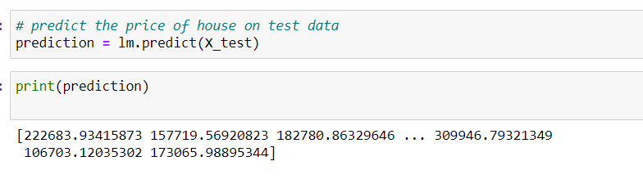

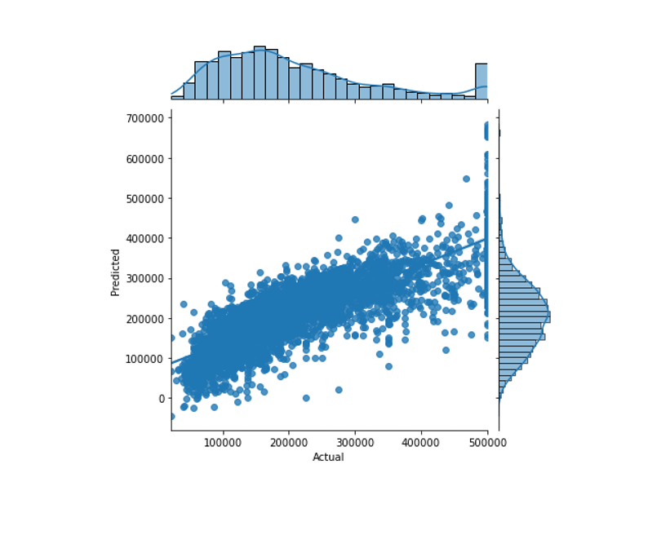

The above chart shows actual vs predicted values. We can see that the model does a decent job of prediction, though there is some margin of error.